**MINOR PROJECT**

**REPORT**

**ON**

**COLLEGE WEBSITE**



**DIPLOMA IN COMPUTER ENGINEERING**

**COMPUTER ENGINEERING 5TH SEMESTER**

**GOVT. POLYTECNIC FOR WOMEN**

**KANDAGHAT,SOLAN**

**SUBMITTED TO:**MR. SANDEEP KHIMTA

**SUBMITTED BY:** SHAGUN : 190710304050

KHUSHI THAKUR : 200720304002

GOVT. POLYTECHNIC FOR WOMEN [KANDAGHAT]

**CERTIFICATE**

This is to certify that the work contained in the Minor Project Report titled “College Website” submitted by Shagun HPTSB Roll No: 190710304050 Khushi Thakur HPTSB Roll No: 200720304002 to the Department of Computer Engineering, Govt. Polytechnic For Women Kandaghat, Distt. Solan(HP) in the partial fulfillment of the requirements for the award of the diploma in the Computer Engineering is a bonafide record of project work carried out during the 27th-September-2021 to 31-December-2021 by them under my supervision and that this project work, in full or in parts, have not been submitted elsewhere for the award of any diploma.

Mr. Sandeep Khimta Mr. Pankaj Kishore Pathik

Project Guide **H.O.D**

Department of computer Engineering Department of Computer Engineering

Govt. Polytechnic for Women, Kandaghat Govt. Polytechnic for Women,Kandaghat

Mr. Dinish Kumar Bindra

Principal

Govt. Polytechnic for Women, Kandaghat, Distt. Solan(H.P)

**STUDENT’S DECLARATION**

We hereby declare that the work contained in this Minor Project Report titled “College Website” submitted by us to the Department of Computer Engineering, Govt. Polytechnic for Women Kandaghat, Distt.Solan (H.P) in partial fulfillment of the requirements for the award of the Diploma in Computer Engineering is a bonafied record of project work carried out during (27th – September-2021 to 31st December-2021) by us under the supervision of Sandeep Khimta and that this project work, in full orin parts, has not been submitted elsewherefor the award of any Diploma. The presented project work represents largely our ideas and work in our words. Where other ideas or words that have been included. We have adequately cited and listed in the reference materials. We have adhered to all principles of academic honesty and integrity.We understand that any violationof the above will cause for disciplinary action by the institute, including revoking the conferred diploma, if conferred and can also evoke penal action from the sources which have not been properly cited or from whom proper permission has not been taken.

Dated: 31-12-2021

Shagun

HPTSB Roll No: 190710304050

Khushi Thakur

HPTSB Roll No: 200720304002

**ACKNOWLEDGEMENTS**

Find and Foremost we wish to thank our Head of Department Mr.Pankaj K, Pathik, our project guide Mr. Sandeep Khimta well as our PrincipalMr. Dinesh K.Bindra without their advice, support and patience this minor Project that had not been possible.

**TABLE OF CONTENTS**

**Title Page No.**

**CERTIFICATE**………………………………………………………02

**STUDENTS DECLARATION**……………………………………...03

**ACKNOWLWDGEMENTS** ………………………………………...04

**CHAPTER 1. INTRODUCTION TO THE PROJECT**06-07

1,1Motivation………………………………………………………….06

1.2 Problem Definition………………………………………………...06

1.3 Feasibility Study………………………………………………….. 07

**CHAPTER 2. PROJECT REQUIREMENT ANALYSIS**

**AND SPECIFICATION**08-16 2.1 Introduction………………………………………………………08

2.2 Fundamental Requirement………………………………………..09-11

2.3 Requirement specifications………………………………………..12

**CHAPTER 3 :PROJECT DESIGN**13-19

3.1 Introduction………………………………………………………..13

3.2SiteMap…………………………………………………………….13-15

3.3 Visual Design………………………………………………………14-19

**REFRENCES**………………………………………………………….20

**CONCLUION**………………………………………………………….21

**CHAPTER-1**

**INTRODUCTION TO THE PROJECT**

**1.1 MOTIVATION**

The purpose of making College Website is to update the existing website by adding some new features to the existing one, checking the updates, errors and checking its working speed.

College Website, as described above, can lead to error free, secure, reliable and fast to work on. It can assist the user to easily see daily updates about their institution. The organization can maintain computerized records without redundant entries. That means that one need not be distracted by information that is not relevant, while being able to reach the information.

The aim is to automate its existing website by the help of new techniques so that website should not become outdated.

**1.2 PROBLEM DEFINITION**

The website was suffering from a series of drawbacks. Since a lot of things needed to be changed in the existing one so, the working of the website has been improved a lot. There were a lot of problem with the sequence and designing in the earlier website it also doesn’t look attractive which causes a drawback to the institutions reputation as it will be complaint from lots of visitors about its appearance because the first thing we look in everything is its presentation so, that need to be good. We also tried that thedata we entered should not keep missing now and **1.3**

**FEASIBILITY STUDY**

After doing the project College Website, study and analyzing all the existing or required functionalities of the system, the next task is to do the feasibility study for the project. All projects are feasible - given unlimited resources and infinite time.

Feasibility study includes consideration of all the possible ways to provide a solution to the given problem. The proposed solution should satisfy all the user requirements and should be flexible enough so that future changes can be easily done based on the future upcoming requirements.

**A. Economical Feasibility**

This is a very important aspect to be considered while developing a project. We decided the technology based on minimum possible cost factor.

* The expenses generated during the Project work was quiet cheap we don’t need to buy something out of our reach to finish this project.
* Most of the facilities were available in the college itself.
* We just had to arrange a PC for us to work on beside functional labs provided by institution itself. The platform where we build our website also provided us most with free of cost services.

**B. Technical Feasibility**

* All the technical resources whether it be the hardware, software or technology to be used in the project is available .
* The projects requirement are fulfilled and its is also feasible to use in our institution.
* We also had correct resources for our project.
* Here we needed a PC with good internet connection and required hardware and software specifications.

**C. Operational Feasibility**

* It is very user friendly and all inputs to be taken all self-explanatory even to a layman.
* It’s not difficult to the website as everything is easy to use we don’t need to provide special trainings to our users .
* Our website is also capable of doing all the work we have assigned to it .

**CHAPTER- 2**

**PROJECT REQUIREMENT ANALYSIS AND SPECIFICATIONS**

**2.1 INTRODUCTION TO PROJECT**

The "College Website" has been developed to override the problems prevailing in the old website This website is supported to eliminate and in some cases reduce the hardships faced by this existing website. Moreover this website is designed for the particular need to carry out operations in a smooth and effective manner.

The application is reduced as much as possible to avoid errors while entering the data. It also provides error message while entering invalid data. No formal knowledge is needed for the user to use this system. Thus by this all it proves it is user-friendly. College Website, as described above, can lead to error free, secure, reliable and fastservices . It can assist the user to concentrate on their other activities rather to concentrate on its lacking functions. Every organization, whether big or small, has challenges to overcome and managing the information of Student, College, Course, Faculty, Fees. Every College Website has different College needs, therefore we designed it with some new features.

**OBJECTIVES OF PROJECT**

* The main objective of the Project on College Website is to manage the details of College, Student, Employee, Course, Fees.
* It manages all the information about College, Faculty, Fees, College. The project is totally built at administrative end and thus only the administrator is guaranteed the access.
* The purpose of the project is to build an application program to reduce the manual work for managing the College, Student, Faculty, Employee.
* It tracks all the details about the Employee, Course, Fees, Activities performed, results of the students and many more.

**2.2 FUNDAMENTAL REQUIREMENTS**

**i. WORDPRESS**



When creating websites for school projects or university courses, the WordPress.com website builder is the ideal tool. First and foremost, it’s both free and intuitive to use. No matter our level of experience, it could launch our new site within 24 hours

So, whether we’re making a photography portfolio or a blog where we can post assignments, here are a few reasons to do it with WordPress.com.

**1.Free to use**

Every WordPress.com website is free for up to 3 GB of storage space.

**2. No site maintenance required**

With a WordPress.com site, we don’t have to perform any of the ongoing updates ourself. All backups, optimization, and maintenance are automatically included with our free website.

**3. A wide selection of templates**

So, whether we’re making a photography portfolio or a blog where we can post assignments, here are a few reasons to do it with WordPress.com.

The versatility of available WordPress.com templates makes all kinds of websites possible. Select the layout that we find most suitable, and we’re set.

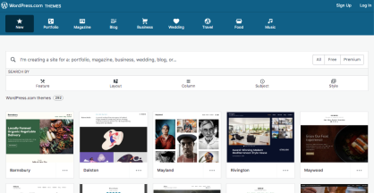

**4. Visual editing**

We don’t need to know how to code to create content on our WordPress.com site. The visual editor makes posting simple and intuitive.

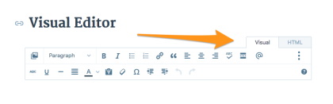

**5. Pages for static content**

If we are posting content on our website that will not change, use the Pages tool. Whether it’s an about page or a class assignment list, this is the perfect place for static content.

**6. Posts for sharing fresh information**

Posts, on the other hand, are ideal for featuring new content as it’s created. We can use posts to share book reviews, class assignments, photos, video, slides, and more.

It’s also possible for classmates, collaborators, or teachers to subscribe and get notifications whenever new posts are published.

**7. Comments**

For sites where we want to facilitate discussion, we can allow comments. The commenting function is enabled by default, but we’re able to turn it off, if we so choose. Go to My Site(s) → Manage → Settings. Click on the Discussion tab. Under “Default Article Settings,” toggle on/off the option to “Allow people to post comments on new articles.”

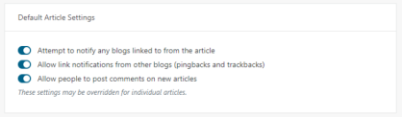

**8. Optional domain name**

If you need your own URL, you can buy one for an $18 annual fee.

**9. Abundant help available**

When you have a question about any part of your site, you can access a host of resources onWordPress.com’s support page.

There are also active forums available, filled with information posted by other users.To get moving on a WordPress.com site for school projects or college courses, go to WordPress.com and hit the Get Started button.

**2.Hardware Specifications**

**Processor:** Intel(R) Core(TM) i3-7020U CPU @ 2.30GHz 2.30GHz

**RAM :**8.00 GB

**Device Id :**28EC94AC-7CBB-45E0-8211-998124794C28

**Device Resolution :** 1920 X 1080

2.3 REQUIRENENT SPECIFACTIONS :

**PROCESSOR :**

Intel(R) Core(TM) i3-7020U CPU @ 2.30GHz 2.30GHz

**RAM :**

8.00 GB

**OPERATING SYSTEM :**

Windows 10 or latest

**SOFTWARE SPECIFICATION :**

WORDPRESS

**CHAPTER – 3**

**PROJECT DESIGN**

**3.1 INTRODUCTION:**

In this process of developing specifications for a candidate system that meet the criteria established in the system analysis. The plan of project provides a review of the different modules in which the project is divided.

**3.2 SITEMAP :**

The sitemap of our website contains the following structure.

HOME

OTHER INFORMATIONON

ABOUT US

VISUAL TOUR

COURCES

STUDENT CORNER

FACILITIES

EXTRA CURRICULAR ACTIVITIES

CONTACT US

ALUMNI

FACULTY STAFF

* **HOME** : This is the main page of our website which contains further pages in it.
* **ABOUT US:**

This page will contain about our :

* INSTITUTE
* SCHEMES
* AICTE EOA
* RTI ACT
* **FACILITIES :**

This page contain about the facilities provided by our institute such as .

* CENTRAL LIBRARY
* HOSTELS
* **FACULTY STAFF :**

This page contains about all the faculty members of our institute teaching the students of particular trade taught in the institute and all the staff members working in the institute in various fields such as clerks, stenos , cleaning, maintenance etc.

* **COURSES :**

This page contains about the courses offered by our institute .There are three courses offered:

* COMPUTER ENGG.
* ELECTONICS AND COMMUNICATION
* PHARMACY
* **EXTRA CURRICULAR ACTIVITIES :**

This page contains about the events performed in our college such as Environment Day celebration, Slogan writing, Dancing competition, Singing competition, Declarations and many more. It also contains about achievements of our college in various fields.

* **OTHER INFORMATION :**

This page contains about the advertisements, notice or mandatory disclosures posted by institute.

* **STUDENT CORNER :**

This contains about all the necessary information about the students like their academic calendar , results, attendance, syllabus etc.

* **ALUMNI :**

This page contains about all the proud Alumnae of our college.These students have achieved the success in their fields and had made our college project.

* **VISUAL TOUR** :

This page contains a visual tour of our college .

* **CONTACT US :**

This page contains the contacts of our Principal Sir, all the HOD’s of various trade and necessary contact required.

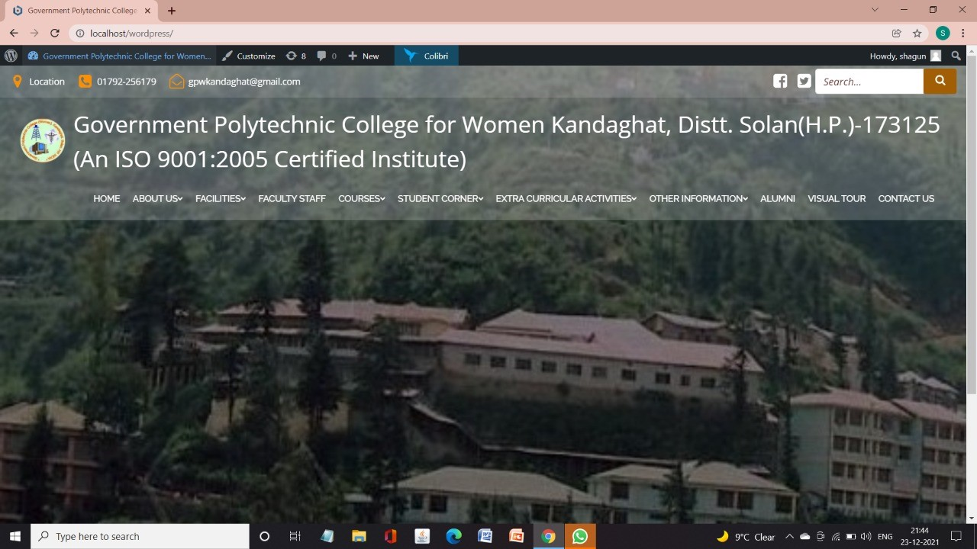**3.3 VISUAL DESIGN OF OUR PROJECT**

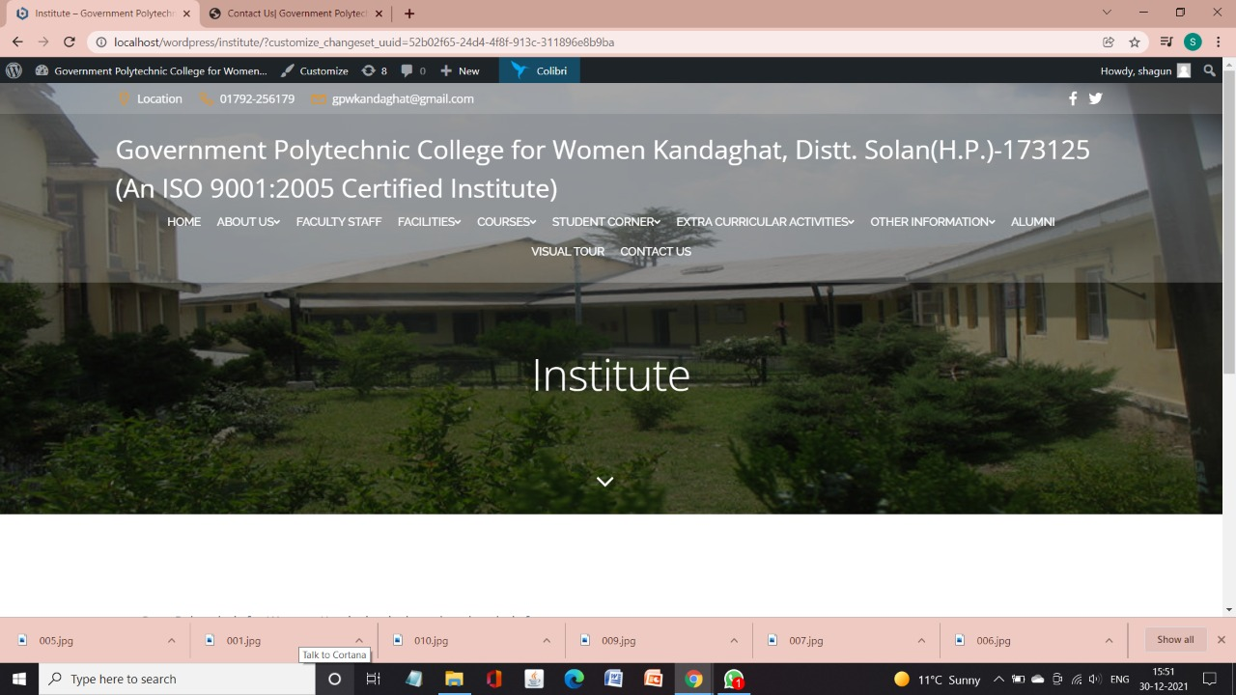

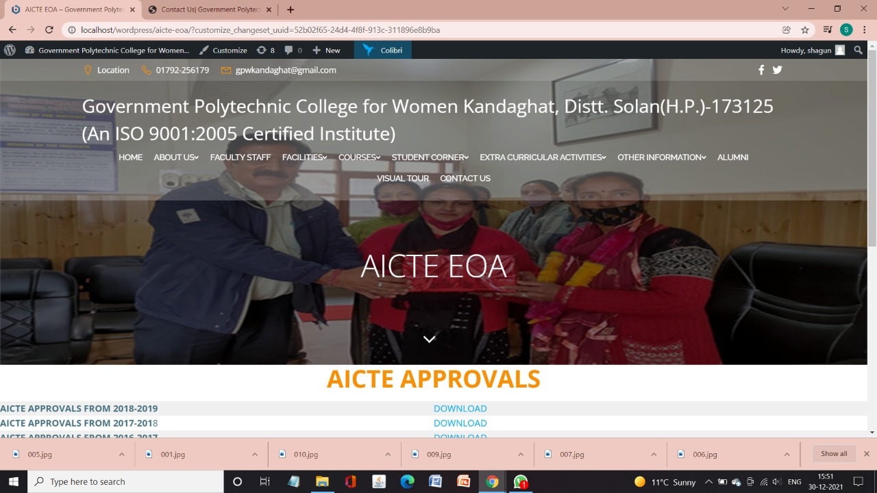

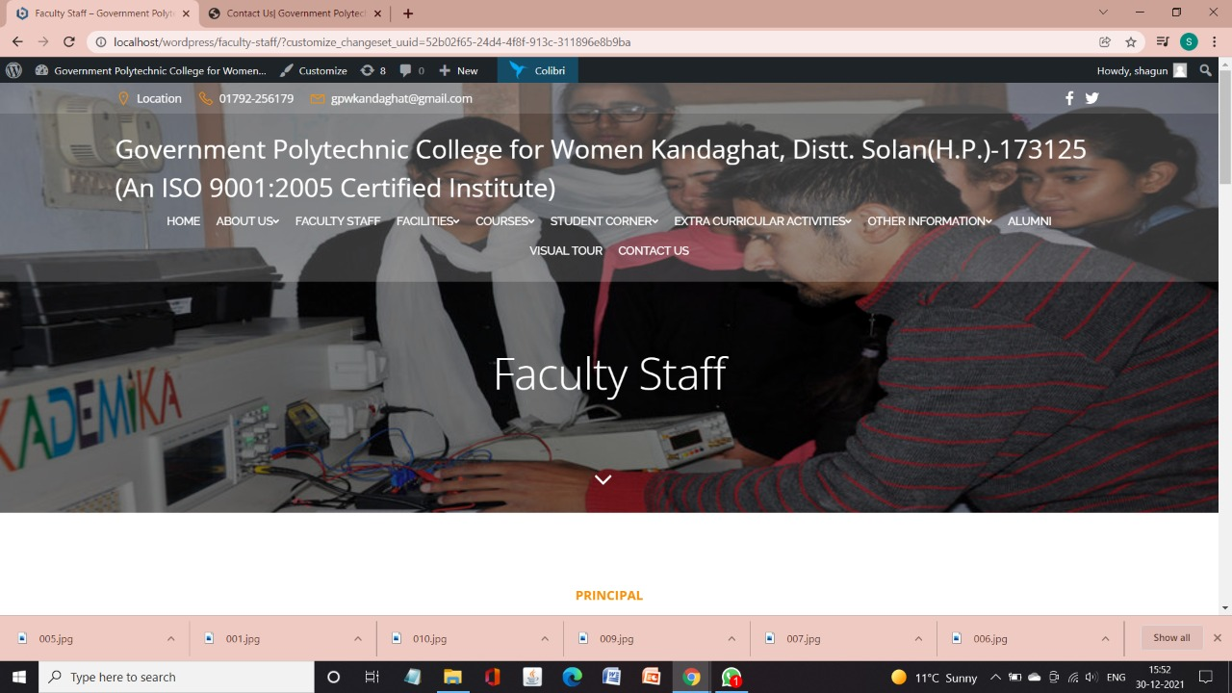

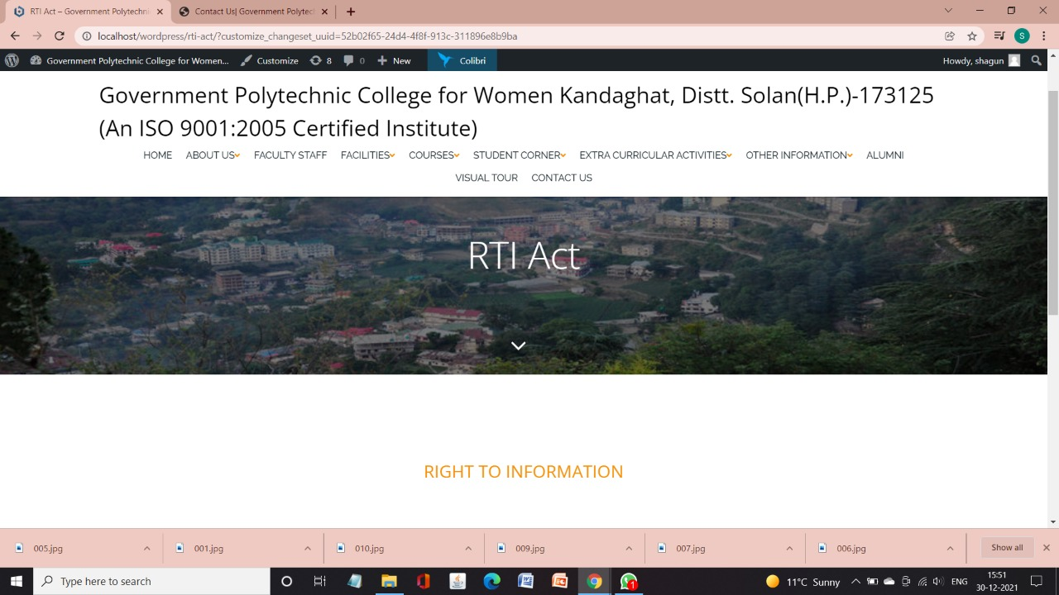

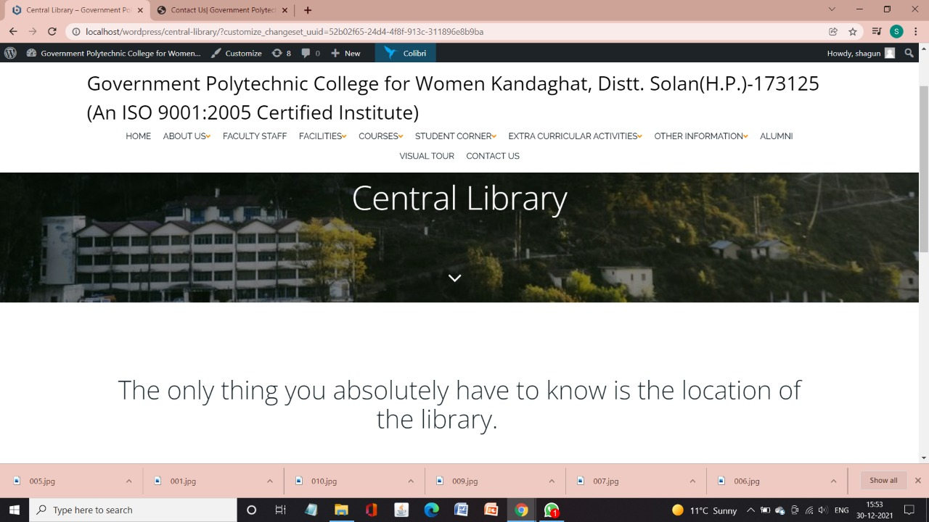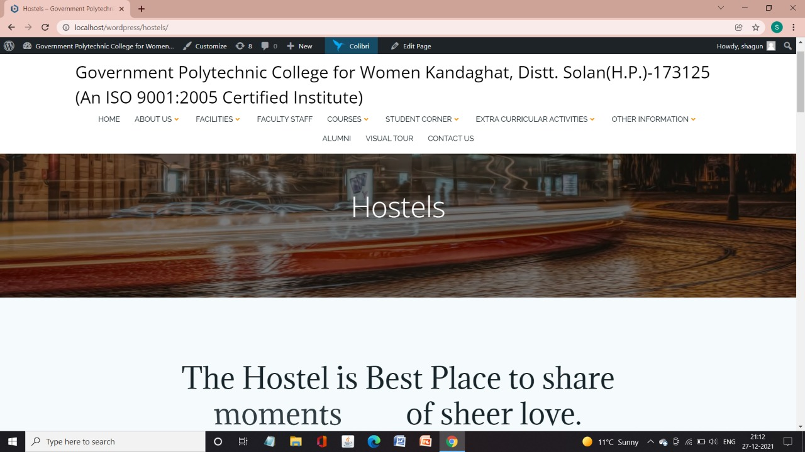**REFRENCES :**

Youtubevedios

Website:

[www.geeksforgeeks.org](http://www.geeksforgeeks.org)

Chandigarh University website

IIT Madras

**CONCLUSION**

The website has been developed for the given condition and is found working effectively. The developed website is flexible and changes can be made easily whenever required . Using the facilities and functionalities of Wordpress the website has been developed in a neat and simple manner, thereby reducing the operator’s work.

The speed and accuracy are maintained in proper way. The user-friendly nature of website is very easy to work with both the higher administration as well as the user’s with little knowledge of computer.

The website is verified and it can be modified as per requirements in the future hence, it can maintained successfully.